SVEUČILIŠTE U ZAGREBU
FAKULTET ELEKTROTEHNIKE I RAČUNARSTVA

ZAVRŠNI RAD br. 454
DEVELOPING A WEB APPLICATION FOR ORGANIZING SPORTING EVENTS
Jura Darko Šlehan

Zagreb, lipanj 2022.

Content
Introduction 1
1. Application description 3
2. Software specifications 7
2.1. Logged out or unregistered user 7
2.2. Logged in user 8
2.3. Explore events 8
2.4. Create a new event 8
2.5. Event participation or cancelation 9
2.6. View a profile 9
3. System architecture and design 10
3.1. Front-end 10
3.2. Back-end 11
3.3. Database 12
3.3.1. SQL databases 12
3.3.2. NoSQL databases 13
4. Implementation and user interface 15
4.1. Technologies and tools 15
4.1.1. React.js 15
4.1.2. ExpressJS 16
4.1.3. MongoDB 16
4.1.4. Mongoose 16
4.1.5. Other technologies and tools 16
4.2. System implementation 16
4.2.1. Registration 17
4.2.2. Log in 18
4.2.3. Event exploration 19
4.2.4. My events 20
4.2.5. Viewing an event 20
4.2.6. New event 23
4.2.7. Profile 24
Conclusion 26
Literature 27
Sažetak 28
Summary 29

Introduction
The subject of this bachelors thesis is the development of a web application for organizing sporting events. Sporting events include all kinds of athletic activities that a person can do in their free time. This application is targeted towards amateur athletes or just regular people who are looking for others who share their interest in recreational sports. This means that you can organize football games, find company for a jog in the morning and invite users to any other similar activity. The idea is that the people who use this app have a chance to meet other sports enthusiasts or just make organization of sporting events with your friends easier.
The idea for this web application came from my friend who frequently organizes football games and has a difficult time finding participants and managing problems such as who to invite and how handle cancelations. Applications that serve this purpose do already exist, but the idea of recreating or perhaps even through time improving this kind of application sounded like an interesting challenge.
This application is going to be a web application because they are accessible to anyone who has access to the Internet. Developing a web application is a very in-demand skill in todays market and it is also a skill that I want to learn and improve, so this thesis is a great chance for me to do so. Most of the applications with this theme are mobile applications and that could be a good second step, but that is also why a web application could be refreshing.
An application that is strongly related to this is a mobile application called Tossli. Tossli is an application where you can meet people to play sports with and reserve playgrounds. You can create and explore sports events, join them and play your favourite sports with other people. This app also allows you to explore sports venues and chat with other people. It is available on Android and iOS. Our aim is to develop an application that serves a similar purpose.
The name of this application is SportEve, which is a combination of words sports and events. It is short and easy to memorize, but it also captures the spirit of this application, and that being the peoples shared interest in sports.
This document consists of 4 chapters:
- Application description
- Software specifications
- System architecture and design
- Implementation and user interface

Application description

My goal is to develop a web application for organizing sporting events. This application will allow users to create sporting events, invite their friends or meet new people who share their interest in sports. Users will be able to create their accounts and once they have done so, they will have the ability to view their profile, as well as other users profiles. Registered users can also view already created events and join them, or create new ones. Details about events and user profiles can be added and edited, that way people can share desired information about events or about themselves. This appication should allow users to simply view and manage their sports activities.

The first page that a user will see when starting this app should look like the one on the Image 1.1.
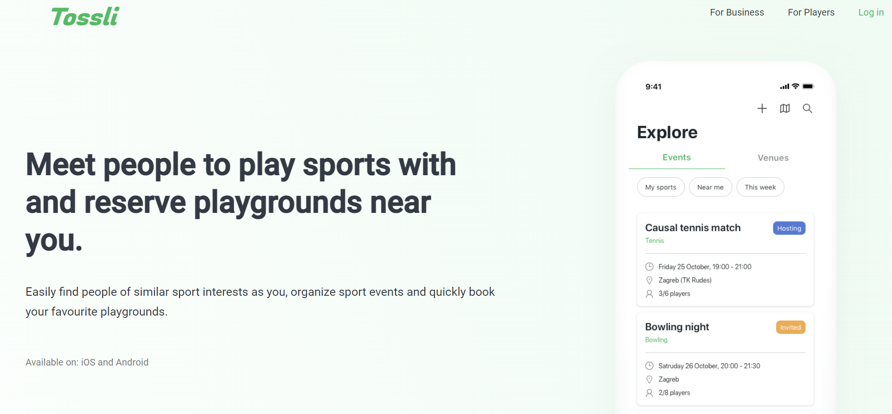
Image 1.1 Register/Login page example
This starting page should also have two main options:
- Register
- Login

If the user does not have a created account, logging in will not work because they do not have an account. By clicking on Register, the user will be taken to a registration page. Users have options to register with their email and password and with their google account. If they choose the first option, they can also enter other information about themselves (for example, their nickname). Once they enter all of the information correctly, the user can submit their register form. The application will save their dana, and they will be redirected to the login page.
However, if the user chooses the option to register with a google account, the application will take them to the page where they will have to choose their google account, and if they have done so successfully, the user will be registered. After that, they will be taken to a page where they can edit additional information about themselves. Once that is done, the user will be sent to the login page.
A registered user can log into the application by clicking on the Login button, which will take them to the login page. There, the user will also choose their preferred login option (using their email and password or google account). A successfull login will finally take them to the main page of this application which is only available to the logged in users.
Once a user is logged in, they will have access to all of the application features. A logged in user can view their profile, which is a page that shows information about the user and the example is shown on the Image 1.2.
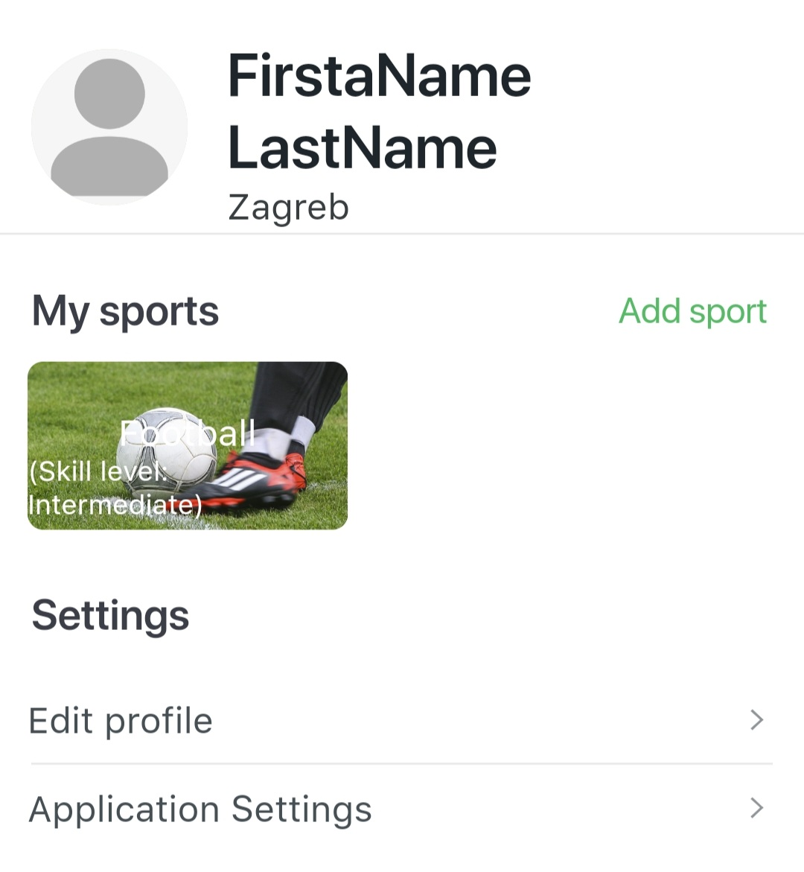
Image 1.2 Profile example

That way a user can choose which information to share with the other users. The information displayed on the profile can also be edited. Aside from viewing their own profile, users will be able to explore other users and view their profiles. Users can view events that other people have created, see details about those events and create their own events. Event exploration might look something like the one shown on the Image 1.3.
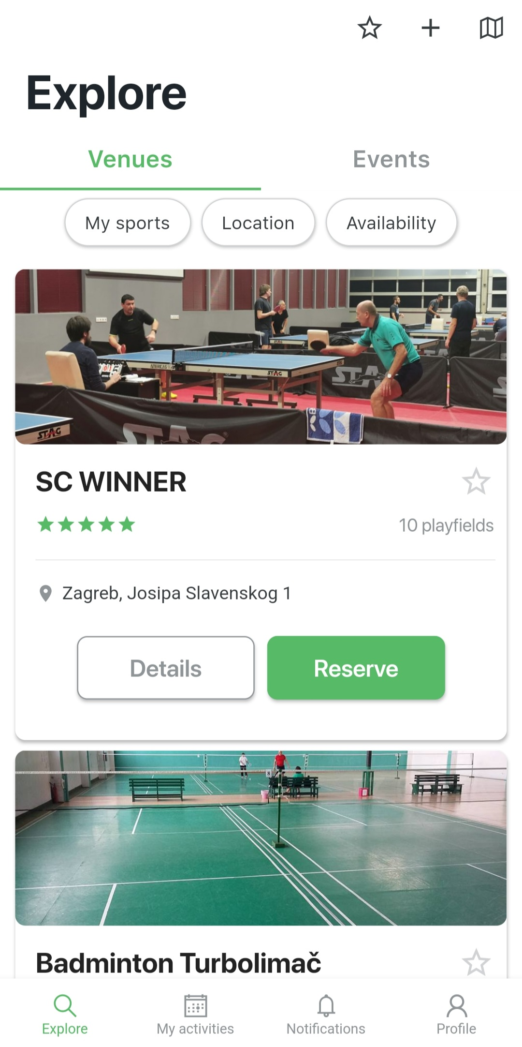
Image 1.3 Explore events page example
Creating events is a key feature and it should be done with a form where a user provides information about the event, as shown on the Image 1.4.
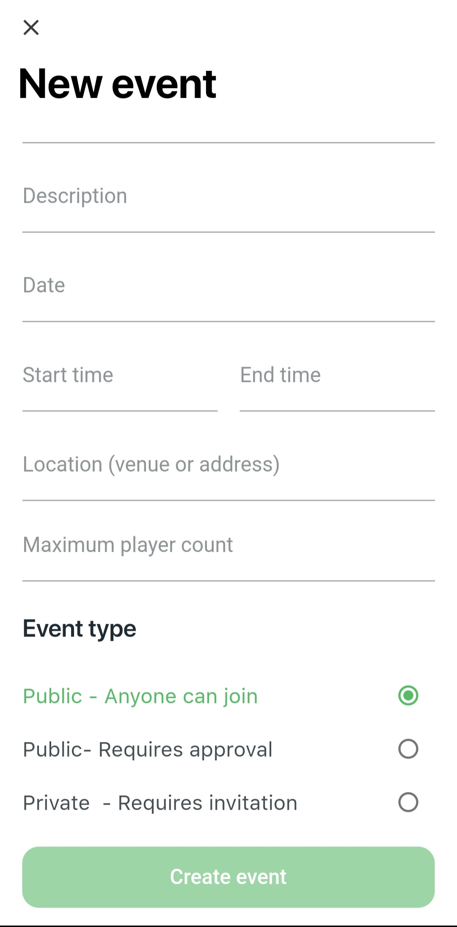
Image 1.4 Event creation example
They will also have an option to see all of their events, the one that they are taking part in or the ones they have created on a separate page.

Software specifications
In order to make an application, a developer needs to know all of its desired functionalities. Use-case diagrams are a great way to visualy represent those functionalities. They discribe the high-level functions and scope of a system and identify the interactions between the system and its actors. The use cases and actors in use-case diagrams describe what the system does and how the actors use it, but not how the system operates internally. It is also important to note that use-case diagrams do not explain the internal operations of the system, they only show what the system does and how it is userd by the actors. In this chapter we are going to go through some of the main functionalities and their use-case (UC for short) diagrams.

Logged out or unregistered user
If the user does not have an account, he can make it by clicking on Register which will take them to the register view which consists of a register form and the google authentication button. This means that the user can register with their email and password by filling out the register form with some information about its account. All of that information can be changed later on the users profile page. Some of those attributes are optional, but the email, password and nickname fields are mandatory and the registration cannot be successfull without them. If the user enters attributes that the application deems invalid, the user will be prompted to change them, and will not be able to submit them. Once the register form is filled out and submitted, the user will be registered and a new account with their information will be created. The other registration option is via their Google account. This means that the application will use their Google profile information in order to register a new user. In this case a new password or email will not be required, but the user will have an option to add some other attributes (like their nickname, full name or their date of birth). After that, the user will be registered and they will have access to their new account.

Logged in user
The main features of this application are available to the user once they are logged in. A logged in user can explore events that the other users have created. This means that they can see other users events all in one place and view each one individually, which provides more detail about the event. The user is also able to join those events, and after that even cancel the participation. The main feature is the creation of new events. Users can do so by providing information about the event in the form and submitting it. After that, the event will be created and other users will be able to join them. The host of the event can also remove and add new participants to the event. If the host cancels his event (only the host of the event can cancel it), that event will no longer exist and users will not be able to see it. Users can see all of the events that they have created of are participating in. Events that have already taken place will be available in the users event history. Every user will have a profile page which will show certain information about them, and some of it will be open for editing when a user desires to do so. Finally, a logged in user can log out at any time, which means that their session has ended.

Explore events
Event exploration consists of exploring new events to participate in and browsing your own events. The purpose of looking through the list of new events is to join and then participate in them. The users events are listed because that way the user can track in which events they are participating in (in the future) or the ones they have already participated in.

Create a new event
Creation of a new event is basically filling a form that consists of some crucial information that users have to provide in order to make it. That way the event becomes available for other users to view or even join.

Event participation or cancelation
If a user chooses an event for viewing, there are some actions that the user can do, depending on their role in that event. A host of a certain event is the person who created that event. Once they have created it, the host can add new participants to the event, remove participants that have already been added or even cancel that event. A user can become a participant of an event if the host has added them or if they have joined the event themselves. Participants of an event can cancel their participation.

View a profile
Each user has their own profile and the ability to view other users profiles. If the users views their own profile, they will also be able to edit certain information about themselves. That, of course, cannot be done with the profiles that belong to another user. Those are only available for viewing.

System architecture and design
The architecture of this system can be divided in three components:
- Front-end
- Back-end
- Database
This three-tier architecture is a very popular application architecture in which all of the components have their role; the front-end or the presentation tier with which the user interacts with, the back-end or the application tier where the data processing happens and the database where the data is stored and managed.

Front-end
The role of the front-end or the presentation tier of the application is to show the user interface to the users and enable them to interact with the application. This tier, in most cases, does not handle any bussinees or process the data that the user has provided. However, the front-end usually validates users' dana and passes that data to the back-end. The communication between the presentation tier and the application tier is classically done through the use of HTTP requests. The HTTP protocol is the main and the most used data transfer method. This communication goes both ways, as the back-end can also send data to the front-end and provide it to the user. All of this is done through HTTP requests and responses. The code that is used to make the presentation tier and its content is HTML (HyperText Markup Language). It offers a wide array of options to stucture the content, from paragraphs to dana tables or images, but in order to style the content better the language that is used is CSS. CSS (Cascading Style Sheets) describes how HTML elements are displayed on screen. A front-end framework that is also frequently used to compliment HTML and CSS is Bootstrap. Bootstrap provides templates for the creation of the user interface. To provide more complex features to the front-end of an application, developers use a programming language called JavaScript. It enables us to create dynamically updating and much more. A famous JavaScript library is React, which is a user interface library and a tool for building components of the user interface. It allows us to build interactive elements on the presentation tier and more about React will be explained in chapter 4.1.1.

Back-end
The back-end is all of the technology required to process the incoming request and generate and send the response to the client. This typically includes three major parts:
- The server. This is the computer that receives requests.
- The app. This is the application running on the server that listens for requests, retrieves information from the database, and sends a response.
- The database. Databases are used to organize and persist data.
A server is simply a computer that listens for incoming requests. Though there are machines made and optimized for this particular purpose, any computer that is connected to a network can act as a server. In fact, you will often use your very own computer as server when developing apps.
he server runs an app that contains logic about how to respond to various requests based on the HTTP verb and the Uniform Resource Identifier (URI). The pair of an HTTP verb and a URI is called a route and matching them based on a request is called routing.
Some of these handler functions will be middleware. In this context, middleware is any code that executes between the server receiving a request and sending a response. These middleware functions might modify the request object, query the database, or otherwise process the incoming request. Middleware functions typically end by passing control to the next middleware function, rather than by sending a response.
Eventually, a middleware function will be called that ends the request-response cycle by sending an HTTP response back to the client.
Often, programmers will use a framework like Express or Ruby on Rails to simplify the logic of routing. For now, just think that each route can have one or many handler functions that are executed whenever a request to that route (HTTP verb and URI) is matched.
The data that the server sends back can come in different forms. For example, a server might serve up an HTML file, send data as JSON, or it might send back only an HTTP status code. You’ve probably seen the status code “404 - Not Found” whenever you’ve tried navigating to a URI that doesn’t exist, but there are many more status codes that indicate what happened when the server received the request.

Database
Databases are commonly used on the back-end of web applications. These databases provide an interface to save data in a persistent way to memory. Storing the data in a database both reduces the load on the main memory of the server CPU and allows the data to be retrieved if the server crashes or loses power.
Many requests sent to the server might require a database query. A client might request information that is stored in the database, or a client might submit data with their request to be added to the database.
A database can be a SQL database or a NoSQL database.

SQL databases
The SQL language is an American National Standards Institute (ANSI) standard, with some dialects, like PL/SQL (in Oracle) and T-SQL (in Microsoft SQL Server). The advantage of writing ANSI-compatible SQL is that you can easily transfer your scripts to another SQL database.
Popular SQL databases include Oracle, MySQL, Microsoft SQL Server, and PostgreSQL. Below, we’ll look at some of the features that make SQL a popular choice among developers.
A common misconception is that SQL databases are considered relational because you can define relations between records in your database using foreign keys. In fact, the name is based on the mathematical concept of a relation, which refers to a collection of unique tuples. A tuple is simply an ordered collection of values.
In an SQL database, a relation is represented as a table, with each tuple in the relation making up a row (commonly called a record) in the table. It’s like a large, formalized Excel spreadsheet for software to use. We call the definition of tables and rows a schema.

In relational databases, you can (and generally should) normalize your data by not storing it redundantly. In the past, storage was expensive, and normalizing your data saved storage.
Having a schema has pros and cons. On the one hand, you always know the entities and values your application expects. On the other hand, it’s not good at dealing with dynamic data.
Having a schema means you can validate your data. For example, the ID field must be unique and may not be NULL (empty). You can also force a foreign key relationship, meaning that a record can’t reference another record that doesn’t exist in your database.
Having a normalized database and these validations in place makes your data reliable. With other SQL perks, like transactions, SQL databases are generally fast, reliable, and robust.

NoSQL databases
A common misconception regarding NoSQL databases is that the “No” means no SQL is used in the database whatsoever. As mentioned earlier, the “No” stands for “not only.” You may find some SQL in NoSQL databases.
Another source of confusion is that there is no single definition of a NoSQL database. In fact, there are four broad categories of NoSQL database:
- Document stores
- Graph databases
- Key-value stores
- Wide-column data stores
Some databases, such as Cosmos DB, span different categories, but NoSQL databases are rarely interchangeable and typically look nothing alike. One thing they generally have in common is that they sacrifice some robustness to gain speed and scalability.
In the development of this web application we are going to use document stores.
Document stores are the most popular type of NoSQL database is the document store. They look the most like traditional SQL databases, except there is no schema and no normalization. Instead of columns and rows, you simply have a collection of whatever it is you put in.
Adding a new field to an entity is easy, but it means some entities have this field defined while others don’t. You can store the same entity multiple times and with different values. You can also easily make a mess out of things!
However, these databases thrive in environments with highly dynamic data and scale much better than SQL databases. Document stores can generally run on multiple servers, while SQL databases are usually tied to a single server. Since document stores don’t have all these pesky field validations, they’re lightning fast!
Popular document stores include MongoDB, DynamoDB, Couchbase, Firebase, and Cosmos DB.

Implementation and user interface

Technologies and tools
In order to create a three tier architecture web application, we need to use some technologies and tools to satisfy all of the requests needed to create each of the components of this application. This chapter will discribe the technologies and tools that were used to create this web-application. It is also important to note that the programming language that was used in the development of this application is JavaScript, so the technologies and tools are going to be based around it. The reason for using JavaScript is that it is one of the most, if not the most used programming language in web development.

React.js
ReactJS tutorial provides basic and advanced concepts of ReactJS. Currently, ReactJS is one of the most popular JavaScript front-end libraries which has a strong foundation and a large community.
ReactJS is a declarative, efficient, and flexible JavaScript library for building reusable UI components. It is an open-source, component-based front end library which is responsible only for the view layer of the application. It was initially developed and maintained by Facebook and later used in its products like WhatsApp & Instagram.
Our ReactJS tutorial includes all the topics which help to learn ReactJS. These are ReactJS Introduction, ReactJS Features, ReactJS Installation, Pros and Cons of ReactJS, ReactJS JSX, ReactJS Components, ReactJS State, ReactJS Props, ReactJS Forms, ReactJS Events, ReactJS Animation and many more.
The main objective of ReactJS is to develop User Interfaces (UI) that improves the speed of the apps. It uses virtual DOM (JavaScript object), which improves the performance of the app. The JavaScript virtual DOM is faster than the regular DOM. We can use ReactJS on the client and server-side as well as with other frameworks. It uses component and data patterns that improve readability and helps to maintain larger apps.

ExpressJS
Express is a minimal and flexible Node.js web application framework that provides a robust set of features for web and mobile applications. With a myriad of HTTP utility methods and middleware at your disposal, creating a robust API is quick and easy. Express provides a thin layer of fundamental web application features, without obscuring Node.js features that you know and love. Many popular frameworks are based on Express.

MongoDB
MongoDB is a document-oriented NoSQL database used for high volume data storage. Instead of using tables and rows as in the traditional relational databases, MongoDB makes use of collections and documents. Documents consist of key-value pairs which are the basic unit of data in MongoDB. Collections contain sets of documents and function which is the equivalent of relational database tables. MongoDB is a database which came into light around the mid-2000s.

Mongoose
Mongoose is an Object Data Modeling (ODM) library for MongoDB and Node. js. It manages relationships between data, provides schema validation, and is used to translate between objects in code and the representation of those objects in MongoDB.

Other technologies and tools
Other technologies and tools that were user are Passport, GoogleOAuth, Git and Visual Studio Code.

System implementation
After all the work of developing an application is done, the app becomes ready for usage. The user interface is one of the most important parts of the web-application, as the user directly interacts with it. This chapter will explain the basic features of this application and how the user interface works.
The starting page is shown on Image 4.5 and that is the first page that the user will see. After that the user can choose wheter to register or login, which will take them to the pages that serve that purpose.
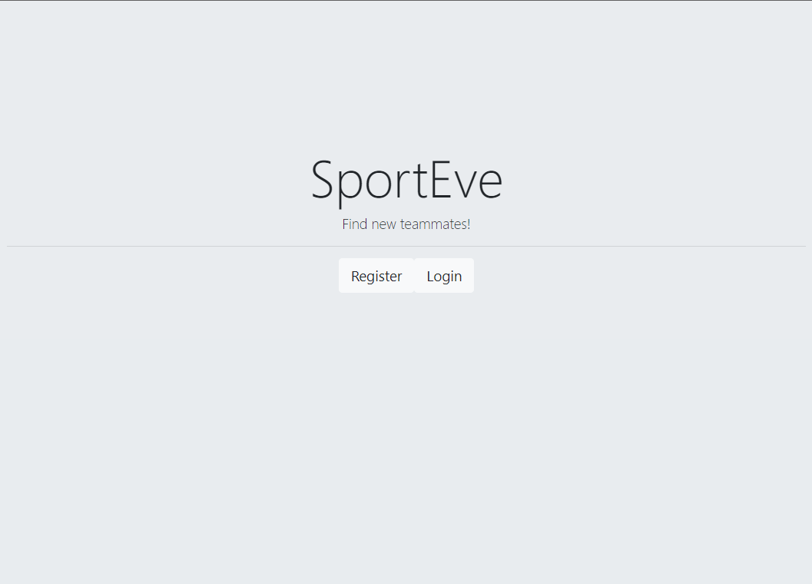
Image 4.5 Starting page

Registration
If the user clicks the register button, the app will take them to the page shown on the Image 4.6. The page shows a form where the user has to provide data in order to create a new account. Aside form the form, there is also a Sign Up with Google button, which gives the user an option to register using their Google account information. If they choose that option, the application will take them to the Google Sign Up page, and if they successfully sign up, a new account will be created and they will be taken to the Login page where they will have to log-in if they want to access the main functionalities of the web-application.
The second option is to fill out the form and register with their email and password, while also providing a a nickname that has to unique, otherwise the Register button will be disabled. Once the user provides the correct data, their account will be created, and they will be prompted to log-in.
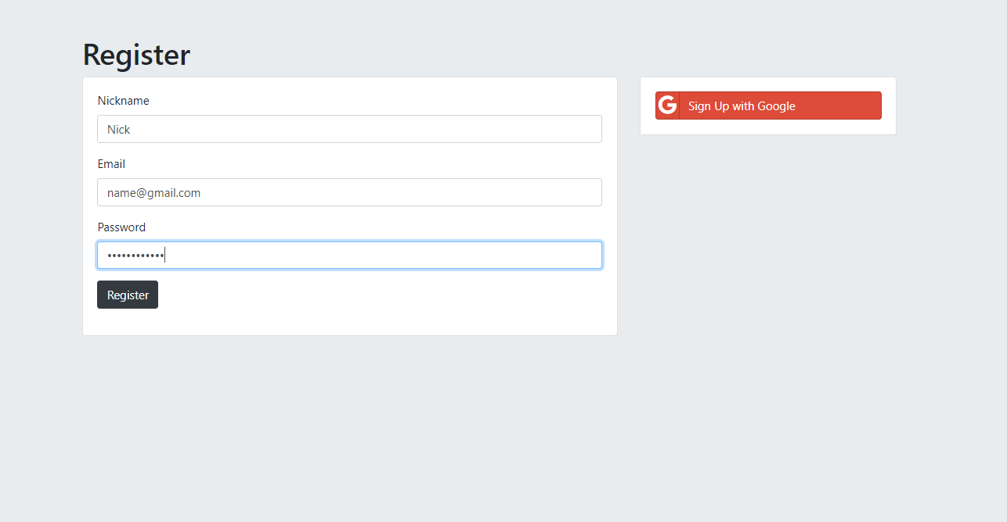
Image 4.6 Register page

Log in
The starting page also provides access to the login page through the Login button. Should the user press that button, they will see the page on Image 4.7. Users that have already registered need to log-in to use this application. If the users does not have an account, they will not be able to log-in. In a similar fashion to the register functionality, a user has two options to choose from when logging-in. Pressing a Sign In with Google button simply loggs the user in using their Google account. That takes them to the main page of the application and unlocks the main functionalities of the application. To log-in with their email and password, the user has to fill the form, and if the data is correct, they will be logged in. The user that has provided incorrect data will be prompted to log in again and will see a message that says that their log-in has failed.
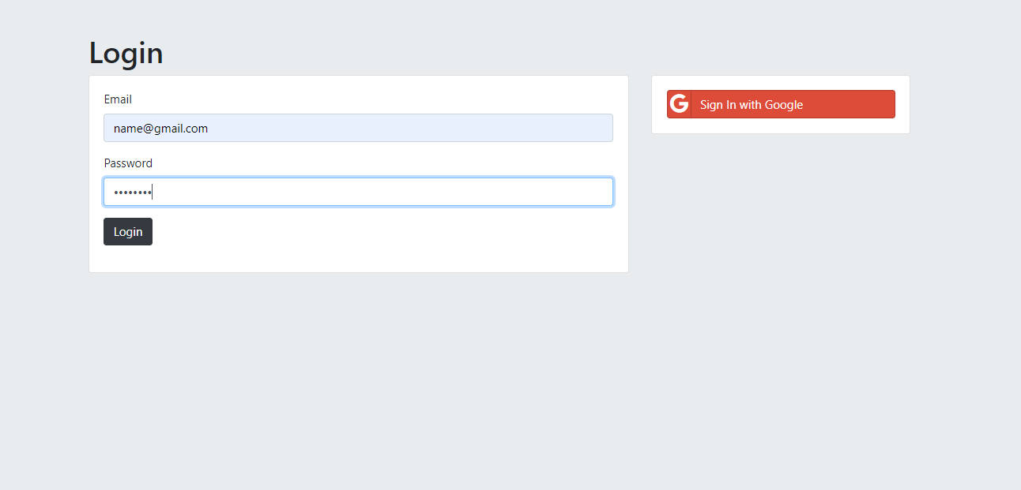
Image 4.7 Login page

Event exploration
The first page a logged in user will see is the event exploration page (Image 4.8). On this page a user will be able to browse through all of the events that the other users have created. Each event is represented with its name and details about it, and by clicking on its name the user will see the event page.
This page, and the other pages (after the log-in) all have a navigation bar. The Logout button on the navigation bar simply logs the user out and ends their session. Other buttons on the navigation bar take the user to certain pages; the event creation page, profile page, my events page and the main page which is the event exploration page.
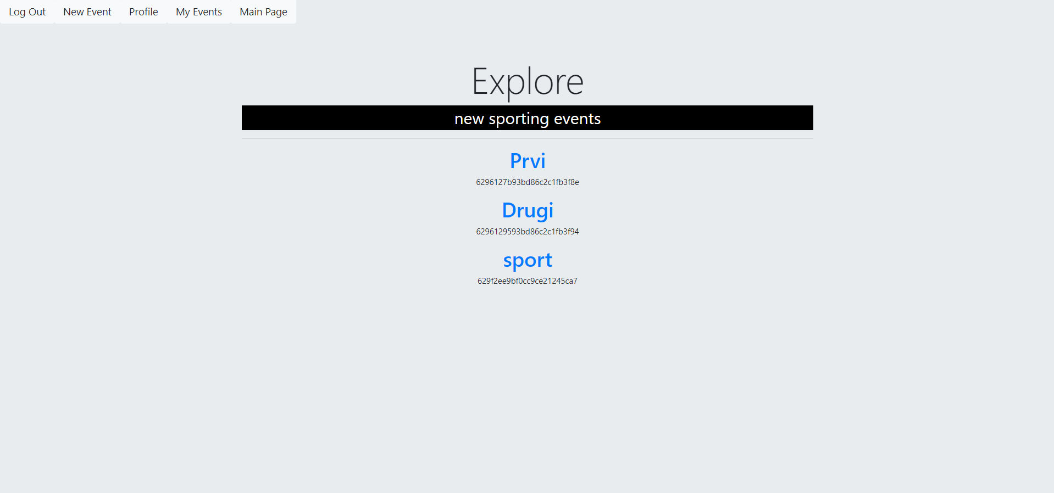
Image 4.8 Event exploration page

My events
My events page shows all of the users events (Image 4.9). Those events include the ones that the user is hosting or participating in. The events are represented by their name and some details about them, all of the event information can be shown by clicking on its name.
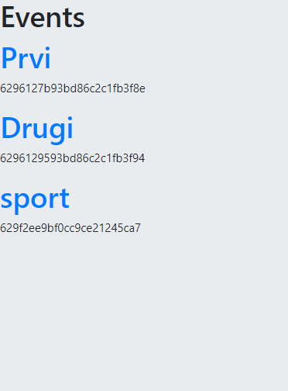
Image 4.9 My events page

Viewing an event
The event page shows the details about the event. Every user can see some of the details about the event, like its title, sport, description, participants, etc. Depending on the role of the user in a given event, they will have access to certain functionalitites concerning that event. If a host clicks on the event they are hosting they will be able to add or remove participants and cancel that event (Image 4.10.). Participants can be removed by clicking on the remove icon, and added by clicking on Add Participants where the host can write the nickname of a user in an autocomplete textbox, choosing the user and adding them. The Cancel event button serves the purpose of deleting that event and all the data that surrounds it.
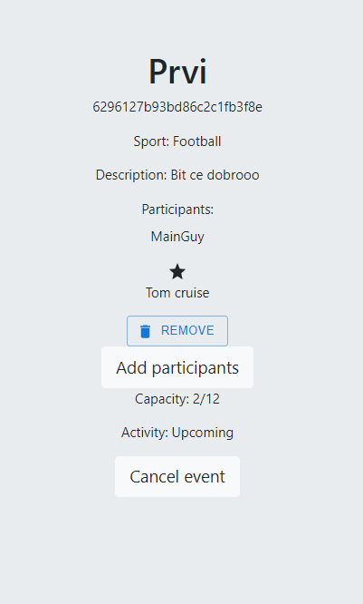
Image 4.10 Event page – host

A user that does not participate in the event that they are viewing has the option to join that event and become a participant (Image 4.11). Participants and non-participants cannot add or remove users from an event. A participant can always cancel their participation in an event by clicking the Cancel button (Image 4.12).
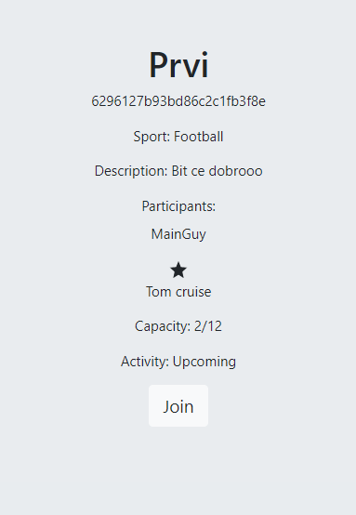
Image 4.11 Event page - non participant
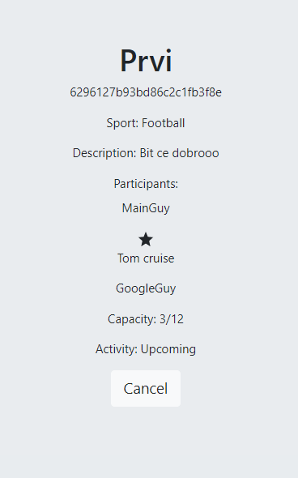
Image 4.12 Event page - participant

New event
To create a new event a user has to fill the form with all the information concerning that event. An event has attributes like the name, sport, maximum number of participants, the description, and the starting and ending time and date. The user has to fill in the form correctly in order to submit the new event.
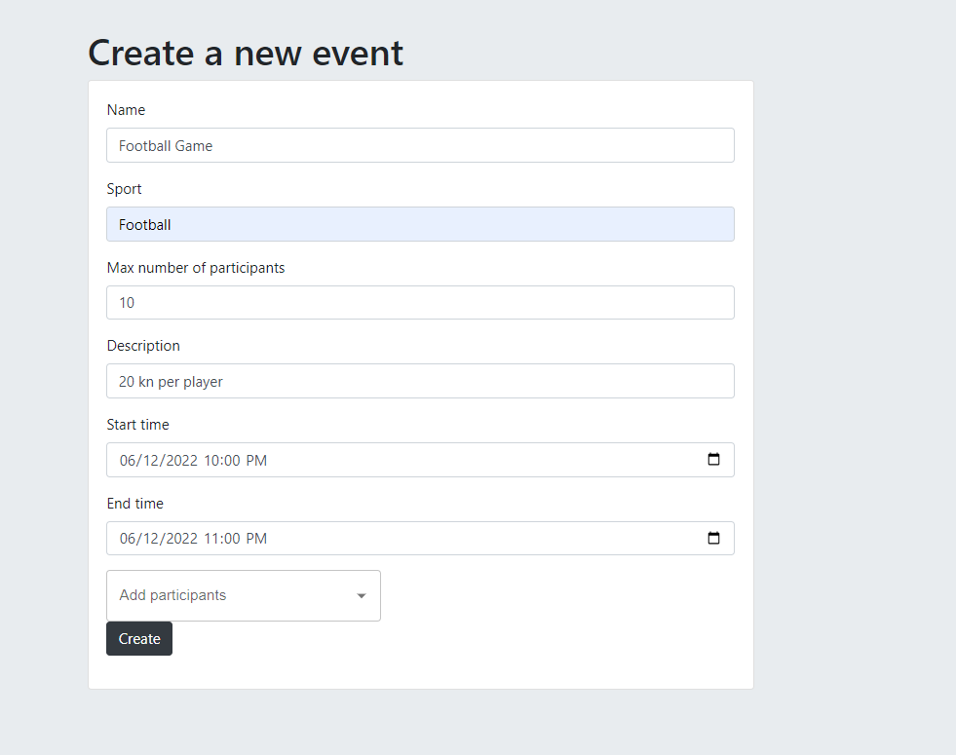

Profile
A profile provides information about the user, like their email, nickname and other. The user can edit certain information by clicking on the edit profile button. Besides viewing their own profile, users can view profiles of other people, but of course, without the option of editing them.
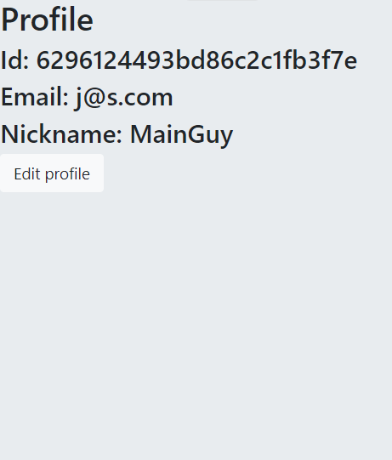

Conclusion
The web application SportEve is an application for creating and joining new sporting events. For the development of this applicatio, we used a three tier architecture.
The three tiers are:
- Front-end
- Back-end
- Database
The programming language that was used for the development of this application is JavaScript. This web application was made using a lot of tools and technologies that are commonly used for web development. Some of the technologies are ReactJS, Express.js and MongoDB. The application uses a NoSql database, which is an alternative to SQL databases.
SportEve provides functionalities that enable users to create accounts, and make new sporting events that they can enjoy with other people who also share their interest in sports. It makes organizing those events easier, which is enabled by the easy to use user interface. This should encourage people to try this and start managing their sporting events more easily.

Literature
- Epstein M., The best VR headset in 2019, PC Gamer, (2019, listopad). Poveznica: https://www.pcgamer.com/best-vr-headset/; pristupljeno 4. listopada 2019.
- Tossli d.o.o., Tossli, (2020). Link: https://www.tossli.com/; accessed May 21, 2022.
- Angela Yu, The Complete 2022 Web Development Bootcamp. Poveznica: https://www.udemy.com/course/the-complete-web-development-bootcamp/; pristupljeno March 7, 2022.
- IBM Cloud Education, Three Tier Architecture, IBM, (2020, October). Link: https://www.ibm.com/cloud/learn/three-tier-architecture; accessed May 25, 2022.
- Šalković, Web-aplikacija za preporuku društvenih događaja, Diplomski rad, Sveučilište u Zagrebu Fakultet Elektrotehnike i Računarstva, 2019
- Code Academy, Back-end architecture, Link: https://www.codecademy.com/article/back-end-architecture; accessed: June 1, 2022
- Javapoint, ReactJS Tutorial, Link: https://www.javatpoint.com/reactjs-tutorial; accessed: May 22, 2022
- CircleCi, SQL vs NoSQL Databases, Link: https://circleci.com/blog/SQL-vs-NoSQL-databases; accessed, June 3, 2022

Sažetak
Cilj ovog završnog rada je prikazati proces razvoja web aplikacije za organizaciju sportskih događaja koju koriste registrirani korisnici. Svrha ove aplikacije je olakšati organiziranje događaja kao i pronalaženje osoba sličnih interesa i prikupljanje određenih informacija o njima. Aplikacija će omogućiti korisniku da napravi profil i poveže se s drugim korisnicima. Korisnici će moći kreirati nove sportske događaje poput rekreativnih nogometnih utakmica i pozivati druge korisnike da sudjeluju. Nadalje, omogućit će svojim korisnicima da međusobno ocjenjuju i pregledavaju svoje profile. Prilikom kreiranja sportskih događaja, korisnici će morati dati određene informacije o događaju poput mjesta, vremena i trajanja.

Summary
The goal of this thesis is to show the process of developing a web application for organizing sporting events that is used by registered users. The purpose of this application is to facilitate organizing events as well as finding people with similar interests and gathering certain information about them. The application will allow the user to make a profile and connect with other users. Users will be able to create new sporting events such as recreational football games and invite other users to participate. Furthermore, it will allow its users to grade each other and view their profiles. When creating sporting events, users will have to provide certain information about the event like the location, time, and duration.

